SIMATS ENGINEERING (SAVEETHA SCHOOL OF ENGINEERING)
Department of Computer Science and Engineering
CO3 ASSESSMENT TOOL 2 – Code Review & Repository Evaluation

Course Code: | CSA10 / CSA1063 | Course Title: | Software Engineering
CO Assessed: | CO3 | Assessment: | Assessment Tool 2 – Code Review & Repository Evaluation
Weightage: | 20% | Total Marks: | 25
CO3 Statement: | Build full-stack applications with an emphasis on containerization, version control, and collaborative development
Student Name: | MEGALA P | Reg. No.: | 192573019
Date: | 15/8/26 | Duration: | 60 minutes

Code of Conduct
I MEGALA P(192573019) (Name / Reg No) certify that this submission is my original work and that I have adhered to the guidelines specified for this assessment. I understand that any violation of academic integrity rules will result in disciplinary action.
Signature of the Student: MEGALA P
Annexure A – Code Review & Repository Evaluation
Instructions to Students:
Each student has been assigned an individual problem statement. Based on the assigned problem statement, perform a Code Review and Repository Evaluation of your project. Analyze the quality of the source code, repository organization, documentation, coding practices, and overall maintainability. Provide appropriate screenshots, code snippets, diagrams, and justifications wherever applicable.

Assignment Questions
- Problem Overview
  - Explain the assigned problem statement and summarize the implemented solution.
  - Describe the project objectives and key functionalities.
- Repository Organization
  - Evaluate the repository structure, folder organization, and file naming conventions.
  - Justify how the repository layout supports maintainability and collaboration.
- Code Quality Review
  - Review the source code for readability, modularity, coding standards, and documentation.
  - Identify strengths and areas for improvement.
- Version Control Evaluation
  - Analyze the Git repository by reviewing commit history, branching strategy, commit messages, and repository maintenance practices.
  - Explain how version control supports collaborative software development.
- Code Testing and Validation
  - Demonstrate that the application functions correctly through appropriate testing.
  - Present test cases, execution results, and screenshots as evidence.
- Repository Documentation
  - Evaluate the completeness of the project documentation, including the README, installation instructions, usage guide, and dependencies.
  - Suggest improvements to enhance usability and maintainability.
- Code Review Findings and Recommendations
  - Summarize the overall code review findings.
  - Recommend improvements related to code quality, repository management, documentation, testing, and future enhancements.

Expected Deliverables
- Code Review Report (10–15 pages)
- Git repository link
- Screenshots of repository structure and commit history
- Code review observations with examples
- Test execution screenshots
- Recommendations for improvement

Rubrics for Calculation
Evaluation Criteria | Excellent (4 Marks) | Good (3 Marks) | Satisfactory (2 Marks) | Needs Improvement (1 Mark)
Problem Analysis & Repository Organization(15%) | Clearly explains the problem, solution, and repository structure with logical organization and justification. | Good explanation with minor omissions. | Basic explanation and repository organization. | Incomplete or poorly organized repository.
Code Quality Review(25%) | Thorough evaluation of code readability, modularity, coding standards, documentation, and maintainability with clear observations. | Good code review with minor gaps. | Basic review with limited analysis. | Superficial or inaccurate code review.
Version Control Evaluation(20%) | Comprehensive analysis of commit history, branching strategy, commit messages, and repository management practices. | Good evaluation with adequate explanation. | Basic evaluation with limited evidence. | Poor or incomplete version control analysis.
Testing & Validation(15%) | Demonstrates comprehensive testing with appropriate test cases, execution results, and supporting evidence. | Good testing with minor omissions. | Basic testing with limited evidence. | Inadequate or missing testing and validation.
Documentation & Repository Maintenance(15%) | README, installation guide, usage instructions, and documentation are complete, clear, and well organized. | Documentation is mostly complete. | Basic documentation with missing details. | Poor or insufficient documentation.
Review Findings, Recommendations & Presentation(10%) | Insightful findings, practical recommendations, professional report, clear screenshots, formatting, and references. | Good recommendations and presentation. | Basic recommendations with acceptable presentation. | Weak conclusions and poor presentation.

Criteria | Mark
System Requirement Analysis (30%) | /5
Selection of Software Architecture (25%) | /5
Architecture Diagram and Component Design (20%) | /5
Component Interaction and Quality Attribute Analysis (15%) | /5
Architectural Justification and Technical Presentation (10%) | /5
TOTAL | /25

Factory Energy Monitoring and Machine Utilization Optimization System

1.Problem Overview
Factory Energy Monitoring and Machine Utilization Optimization System
Modern manufacturing industries operate several machines continuously, consuming large amounts of electrical energy. However, many factories do not have a centralized system to monitor energy consumption and machine utilization in real time. This makes it difficult to identify energy wastage, inefficient machines, idle operating time, and abnormal energy consumption.

The proposed Factory Energy Monitoring and Machine Utilization Optimization System is a software-based solution that collects and analyzes energy and machine usage data. The system monitors parameters such as machine operating status, power consumption, running time, idle time, and utilization percentage.

The collected data is displayed through a centralized dashboard, allowing factory administrators and managers to understand energy usage and machine performance. The system can identify underutilized machines, excessive energy consumption, and abnormal operating conditions. Based on these insights, the system helps management optimize machine schedules and reduce unnecessary energy consumption.
The project follows the objective of developing a maintainable full-stack application with proper repository organization, version control, testing, and documentation, as expected in the given assessment.
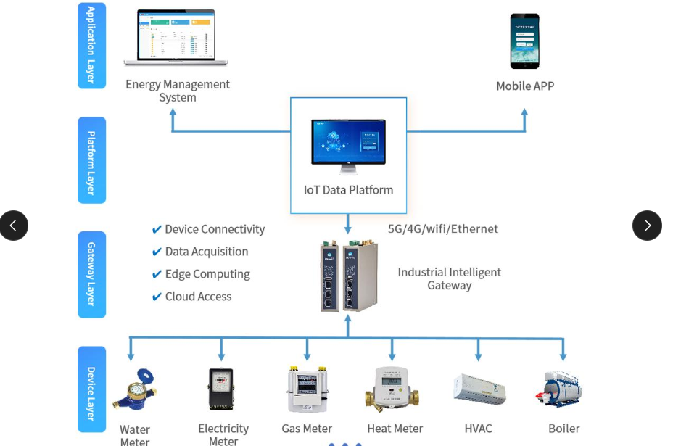
2. Project Objectives
The major objectives of the system are:
- Monitor factory energy consumption in real time.
- Track machine utilization based on operating and idle time.
- Identify machines with high energy consumption.
- Detect machines that are underutilized or frequently idle.
- Provide a centralized monitoring dashboard.
- Generate reports related to energy consumption and machine utilization.
- Provide alerts for abnormal energy usage.
- Help factory managers optimize machine operation schedules.
- Reduce unnecessary energy consumption and operating costs.
- Maintain historical data for analysis and decision-making.

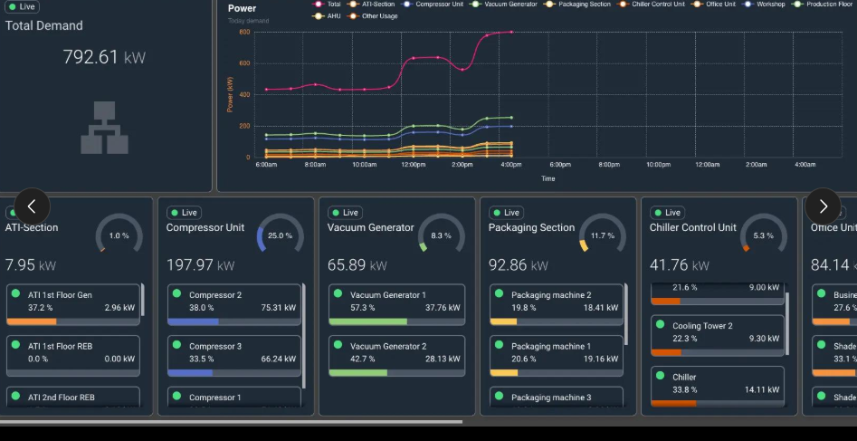
3. Key Functionalities
User Authentication
The system provides secure login functionality for administrators and authorized factory personnel.
Machine Management
Administrators can add, update, delete, and view machine information such as:
- Machine ID
- Machine name
- Machine type
- Production section
- Rated power
- Current status
Energy Monitoring
The system records the energy consumed by individual machines and factory sections. Energy data can be represented using graphs and charts.
Machine Utilization Monitoring
Machine utilization can be calculated using operating time compared with the available production time.
Machine Utilization (%) =
(Machine Operating Time / Available Time) × 100
This helps identify machines that are heavily utilized as well as machines that remain idle for long periods.
Dashboard
The dashboard provides a quick overview of:
- Total energy consumption
- Active machines
- Idle machines
- Machine utilization
- High-energy-consuming machines
- Energy consumption trends.
- Alerts and warnings
Alerts
The system can generate alerts when:
- Energy consumption exceeds a threshold.
- A machine remains idle for a long period.
- Abnormal energy consumption is detected.
- Machine utilization falls below a predefined value.
Reports
The system can generate daily, weekly, and monthly reports for energy consumption and machine utilization.

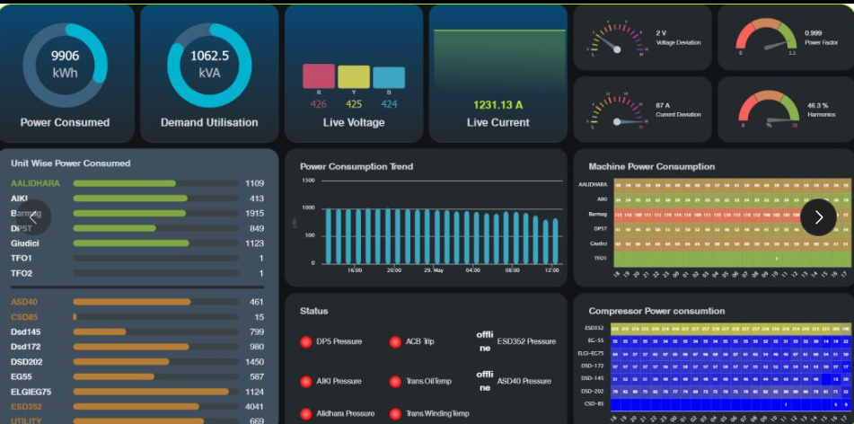

4. Main System Components
1. User Interface
The frontend provides the dashboard through which users can view machine and energy information.
2. Authentication Module
Handles user registration, login, authorization, and access control.
3. Machine Management Module
Maintains information about all machines installed in the factory.
4. Energy Monitoring Module
Collects and stores energy consumption information.
5. Utilization Analysis Module
Analyzes machine operating time, idle time, and utilization percentage.
6. Alert Module
Detects abnormal conditions and sends notifications to authorized users.
7. Reporting Module
Generates energy and utilization reports.
8. Database
Stores users, machines, energy readings, utilization records, alerts, and reports.

7. Repository Organization
A suitable Git repository structure would be:

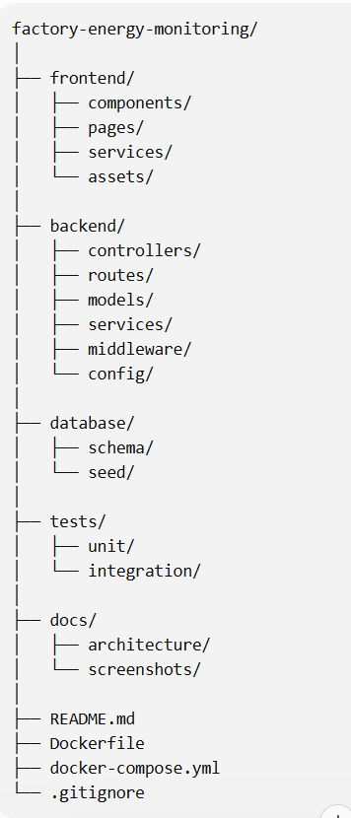

This type of organization separates frontend, backend, database, testing, and documentation, making the application easier to maintain and allowing multiple developers to work on different modules.
The assessment specifically requires evaluation of repository structure, folder organization, naming conventions, and maintainability.

5. Code Quality Review
The source code should follow these principles:
Readability
Variables, functions, classes, and files should use meaningful names.
Example:
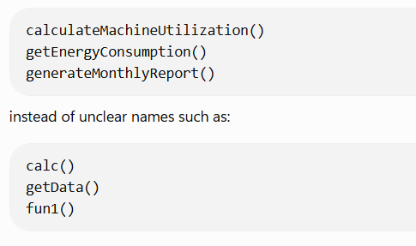
Modularity
Each major functionality should be implemented as an independent module. For example, energy monitoring, machine management, authentication, and reporting should not be tightly coupled.
Reusability
Common functions such as authentication, database access, validation, and error handling should be reusable.
Error Handling
The application should properly handle invalid input, database failures, authentication errors, and unavailable sensor data.
Documentation
Important functions and APIs should have appropriate comments or documentation.

6.Testing and Validation
The system should be tested using different test cases.

Test Case | Input | Expected Result
Login | Valid username/password | User successfully logs in
Login | Invalid password | Error message displayed
Add Machine | Valid machine details | Machine added successfully
Add Machine | Missing machine ID | Validation error
Energy Reading | Valid reading | Reading stored in database
Utilization | Operating = 8 hrs, Available = 10 hrs | Utilization = 80%
Alert | Energy above threshold | Alert generated
Report | Monthly report request | Monthly report displayed
Dashboard | Valid data | Charts and machine status displayed

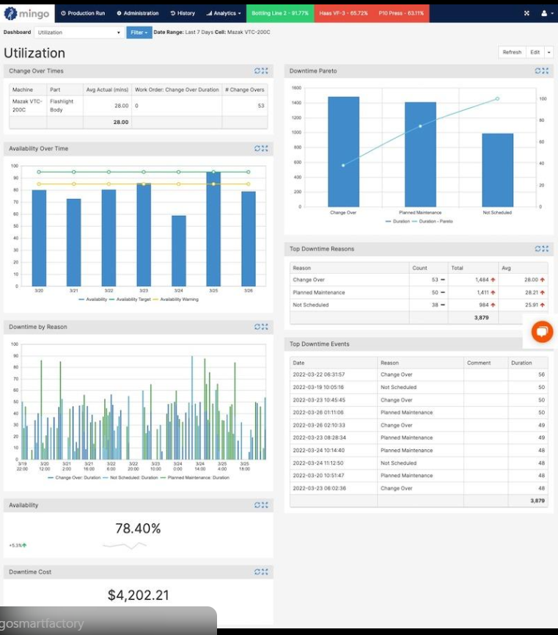

7.Conclusion
The Factory Energy Monitoring and Machine Utilization Optimization System provides an effective solution for monitoring energy consumption and machine performance in a manufacturing environment. The system helps identify energy wastage, machine idle time, excessive power consumption, and underutilized machines through centralized monitoring and analysis.
By using a structured software architecture, proper repository organization, version control, testing, and documentation, the system can be developed as a reliable and maintainable application. The monitoring dashboard provides useful information to factory management for making better operational decisions.

